[Title Here, up to 12 Words, on One to Two Lines]

[Author Name(s), First M. Last, Omit Titles and Degrees]

[Institutional Affiliation(s)]

Author Note

[Include any grant/funding information and a complete correspondence address.]

Abstract

[The abstract should be one paragraph of between 150 and 250 words. It is not indented. Section titles, such as the word Abstract above, are not considered headings so they don’t use bold heading format. Instead, use the Section Title style. This style automatically starts your section on a new page, so you don’t have to add page breaks. Note that all of the styles for this template are available on the Home tab of the ribbon, in the Styles gallery.]

Keywords: [Click here to add keywords.]

[Title Here, up to 12 Words, on One to Two Lines]

[The body of your paper uses a half-inch first line indent and is double-spaced. APA style provides for up to five heading levels, shown in the paragraphs that follow. Note that the word Introduction should not be used as an initial heading, as it’s assumed that your paper begins with an introduction.]

# [Heading 1]

[The first two heading levels get their own paragraph, as shown here. Headings 3, 4, and 5 are run-in headings used at the beginning of the paragraph.]

## [Heading 2]1

[To add a table of contents (TOC), apply the appropriate heading style to just the heading text at the start of a paragraph and it will show up in your TOC. To do this, select the text for your heading. Then, on the Home tab, in the Styles gallery, click the style you need.]

[Heading 3]. [Include a period at the end of a run-in heading. Note that you can include consecutive paragraphs with their own headings, where appropriate.]

[Heading 4]. [When using headings, don’t skip levels. If you need a heading 3, 4, or 5 with no text following it before the next heading, just add a period at the end of the heading and then start a new paragraph for the subheading and its text.] (Last Name, Year)

[Heading 5]. [Like all sections of your paper, references start on their own page. The references page that follows is created using the Citations & Bibliography feature, available on the References tab. This feature includes a style option that formats your references for APA 6th Edition. You can also use this feature to add in-text citations that are linked to your source, such as those shown at the end of this paragraph and the preceding paragraph. To customize a citation, right-click it and then click Edit Citation.] (Last Name, Year)

# Introduction

Similarity between items is an important aspect in many area of psychology, e.g., categorization (Nosofsky & Palmeri, 1997), memory (Farrell, 2006; Jackson, Linden, Roberts, Kriegeskorte, & Haenschel, 2015; Nosofsky & Kantner, 2006), and reasoning (Heit & Rubinstein, 1994). The typical task for acquiring similarity matrix is the Paired-Comparison task {cites}, which askes participants to rate the similarity of two items at once, thus the number of trials requires to compare items is

|  |  |  |
| --- | --- | --- |
|  |  |  |

Because the number of necessary comparisons to complete a full similarity matrix increase exponentially, acquiring similarity matrix is often impractical when the number of items reaches certain number. For example, the similarity matrix of 50 items requires 1225 trials, which will require two hours to complete the task.

In this study, we present a new method for acquiring the similarity matrix quickly and accurately, Multi-Items Rearrangement task. The task presents multiple items at once, and participants are asked to rate those items in the single trial, which reduced the number of trials required for completing the similarity matrix drastically. In this article, we first introduce the Multi-Items Rearrangement task in detail, then we will introduce two experiments to test the reliability and validity of the Multi-Items Rearrangement task.

# Multi-Items Rearrangement Task

The Multi-Items Rearrangement task presents multiple items at once, and participants were instructed to rearrange the items based on the similarity between items. Closer distance between the items indicates higher similarity, or vice versa. Figure 1 shows the procedure of a trial in the Multi-Items Rearrangement task. Because the Multi-Items Rearrangement task presents multiple items at once, a subset of the similarity matrix can be acquired in a single trial. Therefore, the Multi-Items Rearrangement task requires less trials to complete the full similarity matrix.

The Multi-Items Rearrangement task divide the items pool into several subsets, and two subsets are presented in a trial, thus, the task only requires the combinations with all the subsets. Assuming the item pool has items and is divided into subsets has items each, there are subsets. The number of trials require to completely compare all the subsets is

|  |  |  |
| --- | --- | --- |
|  |  |  |

In the case where each subset contains only item, the Multi-Items Rearrangement task requires the same number of trials as the Paired-Comparison task, since there are only two items are compared at once. If the subset contains half of the items, all the items are compared at once, and only a single trial is required to complete the similarity matrix. However, it is unrealistic to present all the in a trial. Presenting large amount of the items in a trial increases the complexity for rearrangement. In the study, we presented 8 items at once in a single trial, i.e., 4 items per subset.

Other than time efficiency, the Multi-Items Rearrangement task also provides a finer scale for reporting similarity comparing to Paired-Comparison task. In the Paired-Comparison task, participants are limited to the similarity scale used in the task (normally either 5-points scale or 9-points scale). Many pairs will fall into the same similarity rating despite there might be subtle differences between pairs. In the Multi-Items Rearrangement task, the similarity between a pair of items is reported through the distance between items, and the distance is a much finer scale comparing to the 9-point scale and is only limited by the resolution of the screen. Hence, participants are able to reflect their objective similarity more precisely.

Another advantage of the Multi-Items Rearrangement task over the Paired-Comparison task is that the Multi-Items Rearrangement task is affect less by diagnosticity effect {Tversky 1977} by presenting multiple items at once. Previous studies found that the item set affects the rating of the similarity {cite}. For example, the similarity rating between green and blue is more dissimilar if the pair is presented alone then if the pair is presented along with red. In the Paired-Comparison task, participants are gradually exposed to the item set, hence the standard of the similarity rating changes throughout the task. In the Multi-Items Comparison task, participants are exposed to multiple items at once, hence more items are introduced at once, which reduced the effect of from the item set.

Although the Multi-Items Rearrangement task has many advantage of acquiring similarity matrix, the reliability and the validity of the task is not yet explored. Thus, we will introduce two experiments which examine the reliability and the validity on different material. Discrete features are commonly used in the psychology experiment {cite}. Therefore, in the Experiment 1, we used the material constructed from multiple discrete features. In the Experiment 2, we used the material from a continuous dimension.

# Experiment 1

In the Experiment 1, we tested the validity and the reliability of the Multi-Items Rearrangement measurement. The experiment is separated into two blocks. The first block employed the Multi-Items Rearrangement measurement to measure the similarity between abstract faces. The second block used the Paired comparison measurement to validate the result acquired from the Multi-Items Rearrangement measurement.

## Method

Participants. Ten students recruited from University of Zürich. Participants were rewarded with course credits or 30 Swiss Francs after completed the experiment.

Materials. Both Multi-Items Rearrangement task and the Paired-Comparison task shared the same set of stimuli. Color patches are used in the practice trials. The colors are randomly selected from all the possible colors in the 24 bits RGB color space. Abstract faces are used in the experiment trials. The faces are varied on four dimensions: the width between eyes, the height of eyes, the length of nose, and the position of mouth, with each dimensions have two possible configurations. The faces are shown in the Figure 2.

Procedure. Experiment 1 is consisted of two identical sessions, and the sessions are carried in two different days. Each session contains two blocks. The first block is the Multi-Items Rearrangement measurement task, and the second block is the Paired comparison measurement task. On average, each session takes about 45 minutes.

Multi-Items Rearrangement Task. The Multi-Items Rearrangement task consists of two practice trials and 12 experiment trials. In each trials, 8 items were randomly scattered on the screen without overlapping. Participants were instructed to rearrange the items by using mouse to drag-and-drop the items, and the distance between items should reflect the similarity between the items, where the farther distance between items indicates the more dissimilar between items. After participants were satisfied with the arrangement of the items, they can press space bar to continue to next trial. Participants were instruction to take as long as they want to rearrange the items.

The Multi-Items Rearrangement task requires 6 trials to complete the similarity matrix between 16 items. We repeated the procedure twice in order to obtain more accuracy measurement of the similarity matrix. The items were rearranged into different subgroup for the second repetition.

Paired-Comparison Task. The paired comparison task consists of 4 practice trials and 240 experiment trials. In each trial, two items were presented on the screen with a 9 points scale below the items. Participants were instructed to rate the similarity between the two items by clicking on the 9 points scale, with 1 to be the most similar, and 9 to be the most dissimilar. After the similarity is selected, a blank screen appeared for 1 second and was followed by the next trial. Participants were instructed to take as long as they want to complete the trial.

The Paired-Comparison task requires 120 trials to complete the similarity matrix of 16 items. We repeated the measurement twice in order to increase the accuracy of the similarity matrix.

## Results

The similarity matrix acquired from the Multi-Items Rearrangement task is based on the distance between items in the trial. If the distance between two items were measured multiple times, the average of the distance is used as the similarity between the items. The similarity matrix acquired from the Paired-Comparison task is based on the rated similarity between items. Similar to the Multi-Items Rearrangement task, if an items pair is rated multiple times, the similarity between the items pair is calculated as the average between ratings. The similarity matrices acquired from both tasks were normalized by rescaling the maximum dissimilarity in the matrix to 1. The normalization ensures that the similarity matrix acquired from the Multi-Items Rearrangement task and the similarity matrix acquired from the Paired-Comparison task are under the same scale.

To test the reliability of Multi-Items Rearrangement task and the Paired-Comparison task, we compare the similarity matrixes acquired from the first session and the second session. The comparison between the similarity matrices is done through Random Skewers method (Cheverud & Marroig, 2007). The correlation between the similarity matrices acquired from first session and the second session for both tasks of each participant are listed in Table 1. To test the validity of the Multi-Items Rearrangement task, the similarity matrices acquired from Multi-Items Rearrangement task and the similarity matrices acquired from Paired-Comparison task were compared with the Random Skewers method. The correlation between the similarity matrices are listed in Table 1, where the lowest correction is 0.85. To ensure both similarity matrices are aligned, we plotted the with acquired similarity matrices with Multidimensional Scaling, as shown in Figure 3.

The average time required to complete the Multi-Items Rearrangement task is 475.6s, and the Paired-Comparison task takes average 905.1s to complete. The time required for both tasks were compared in R (R. Core Team, 2016) with BayesFactor package (Morey & Rouder, 2015), and the data strongly supported that Paired-Comparison task takes longer than Multi-Items Rearrangement task ().

# Experiment 2

In Experiment 2, we replicated the same method used ion Experiment 1 with different material. The faces in Experiment 1 were defined with multiple discrete features. In Experiment 2, we want to test the ability of measuring the similarity matrix with material with continuous feature of Multi-Items Rearrangement task, hence we used color patches as material.

### Method

Participants. Ten students recruited from University of Zürich. Participants were rewarded with course credits or 30 Swiss Francs after completed the experiment. All the participants in Experiment 2 did not participant in Experiment 1.

Materials. Both Multi-Items Rearrangement task and the Paired-Comparison task shared the same set of stimuli. The faces from the Experiment 1 were used in the practice trials. Color patches were used in the experiment trials. 16 color patches were selected from a color wheel which was created in the CIE L*a*b* color space with radius of 60 and centered at luminance set to 70, set to 20, and set to 38. All the color patches were evenly distributed on the color wheel. The color patches are shown in the Figure 4, and the RGB values of the color patches are shown in Table 2.

Procedure. The procedure of the Experiment 2 is the same as the procedure of the Experiment 1.

## Results

The similarity matrices acquired from both tasks were normalized in the same way as we did in Experiment 1. For the reliability test for both tasks, we again applied the Random Skewers method to the similarity matrices acquired from the first and the second session. The correlations between the similarity matrices are shown in the Table 3. The minimum reliability of the Multi-Items Rearrangement task is 0.79, and the minimum reliability of the Paired-Comparison task is 0.70. To test the validity of the Multi-Items Rearrangement task, we compared the average similarity metric acquired from both sessions of the Multi-Items Rearrangement task and the average similarity matric acquired from both sessions of the Paired-Comparison task with Random Skewers method. The correlations are shown in Table 3, and the lowest validity is 0.77. The similarity matrices acquired from both tasks were plotted MDS in Figure 5.

The average time for completing the Multi-Items Rearrangement task is 338.3 seconds, and the average time for completing the Paired-Comparison task is 713.9 seconds. The time required to complete both tasks were compared with BayesFactor package in R. The results shown strong evidence supports the time required to complete the Multi-Items Rearrangement task is shorter than the Paired-Comparison task ().

# Discussion

## Reliability and Validity

## Advantage and Disadvantage

References

Cheverud, J. M., & Marroig, G. (2007). Research Article Comparing covariance matrices: random skewers method compared to the common principal components model. *Genetics and Molecular Biology*, *30*(2), 461–469. https://doi.org/10.1590/S1415-47572007000300027

Farrell, S. (2006). Mixed-list phonological similarity effects in delayed serial recall. *Journal of Memory and Language*, *55*(4), 587–600. https://doi.org/10.1016/j.jml.2006.06.002

Heit, E., & Rubinstein, J. (1994). Similarity and property effects in inductive reasoning. *Journal of Experimental Psychology: Learning, Memory, and Cognition*, *20*(2), 411.

Jackson, M. C., Linden, D. E. J., Roberts, M. V., Kriegeskorte, N., & Haenschel, C. (2015). Similarity, not complexity, determines visual working memory performance. *Journal of Experimental Psychology: Learning, Memory, and Cognition*, *41*(6), 1884–1892. https://doi.org/10.1037/xlm0000125

Morey, R. D., & Rouder, J. N. (2015). BayesFactor: omputation of Bayes Factors for Common Designs (Version R package version 0.9.12-2). Retrieved from https://CRAN.R-project.org/package=BayesFactor

Nosofsky, R. M., & Kantner, J. (2006). Exemplar similarity, study list homogeneity, and short-term perceptual recognition. *Memory & Cognition*, *34*(1), 112–124. https://doi.org/10.3758/BF03193391

Nosofsky, R. M., & Palmeri, T. J. (1997). An exemplar-based random walk model of speeded classification. *Psychological Review*, *104*(2), 266–300. https://doi.org/10.1037/0033-295X.104.2.266

R. Core Team. (2016). *R: A Language and Environment for Statistical Computing*. Vienna, Austria. Retrieved from http://www.R-project.org/

Footnotes

1[Add footnotes, if any, on their own page following references. For APA formatting requirements, it’s easy to just type your own footnote references and notes. To format a footnote reference, select the number and then, on the Home tab, in the Styles gallery, click Footnote Reference. The body of a footnote, such as this example, uses the Normal text style. (Note: If you delete this sample footnote, don’t forget to delete its in-text reference as well. That’s at the end of the sample Heading 2 paragraph on the first page of body content in this template.)]

Tables

Table 1

Reliability and Validity of Experiment 1.

|  |  |  |  |
| --- | --- | --- | --- |
| Participant | Paired-Comparison | Multi-Items Rearrangement | Validity |
| 1 | 0.98 | 0.91 | 0.95 |
| 2 | 0.87 | 0.84 | 0.91 |
| 3 | 0.78 | 0.80 | 0.91 |
| 4 | 0.79 | 0.81 | 0.85 |
| 5 | 0.87 | 0.96 | 0.87 |
| 6 | 0.81 | 0.74 | 0.91 |
| 7 | 0.94 | 0.83 | 0.87 |
| 8 | 0.95 | 0.86 | 0.86 |
| 9 | 0.91 | 0.95 | 0.91 |
| 10 | 0.85 | 0.71 | 0.89 |

Table 2

The RGB values of the color patches used in Experiment 2.

|  |  |  |  |
| --- | --- | --- | --- |
| Item | R | G | B |
| 1 | 255 | 90 | 109 |
| 2 | 255 | 97 | 65 |
| 3 | 255 | 116 | 0 |
| 4 | 255 | 137 | 0 |
| 5 | 238 | 156 | 0 |
| 6 | 204 | 171 | 0 |
| 7 | 170 | 182 | 0 |
| 8 | 141 | 188 | 49 |
| 9 | 118 | 191 | 101 |
| 10 | 107 | 190 | 145 |
| 11 | 117 | 180 | 180 |
| 12 | 149 | 176 | 204 |
| 13 | 191 | 162 | 213 |
| 14 | 234 | 144 | 206 |
| 15 | 255 | 122 | 183 |
| 16 | 255 | 101 | 150 |

Table 3

Reliability and Validity of Experiment 2.

|  |  |  |  |
| --- | --- | --- | --- |
| Participant | Paired-Comparison | Multi-Items Rearrangement | Validity |
| 1 | 0.96 | 0.92 | 0.96 |
| 2 | 0.94 | 0.85 | 0.91 |
| 3 | 0.89 | 0.89 | 0.90 |
| 4 | 0.93 | 0.86 | 0.93 |
| 5 | 0.94 | 0.89 | 0.95 |
| 6 | 0.98 | 0.83 | 0.93 |
| 7 | 0.97 | 0.95 | 0.97 |
| 8 | 0.99 | 0.84 | 0.96 |
| 9 | 0.70 | 0.79 | 0.77 |
| 10 | 0.93 | 0.83 | 0.93 |

Figures

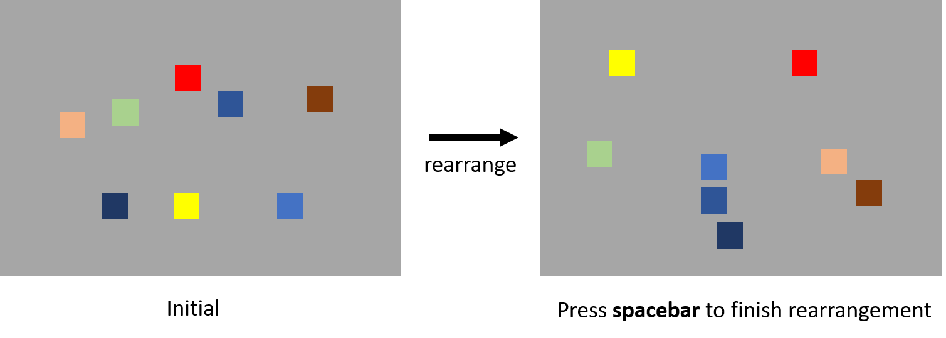

Figure 1. The procedure of the Multi-Items Rearrangement task. The left figure is the initial presentation of the items. Participants were asked to rearrange the items according to the similarity between the items by using mouse to click-and-drop. The right figure is a potential outcome after the rearrangement.

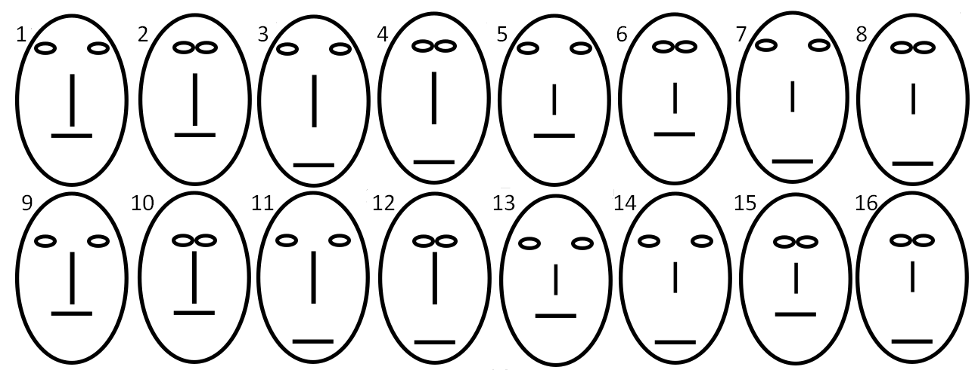

Figure 2. The material used in the Experiment 1. The faces are constructed with four dimensions: the width between eyes, the height of eyes, the length of nose, and the position of mouth.

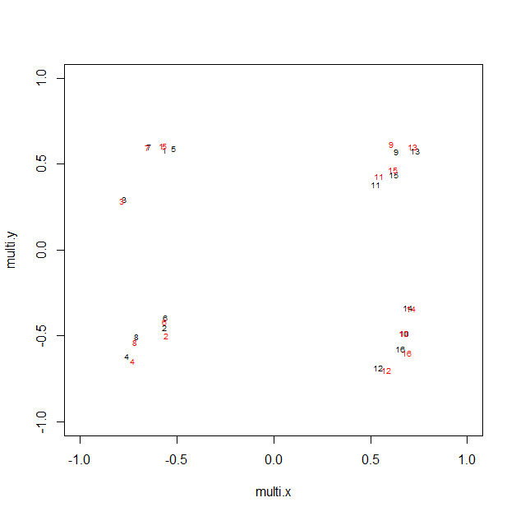

Figure 3. The MDS results of the similarity matrices acquired from the Multi-Items Rearrangement task and the Paired-Comparison task. The numbers indicate the items in Figure 2.

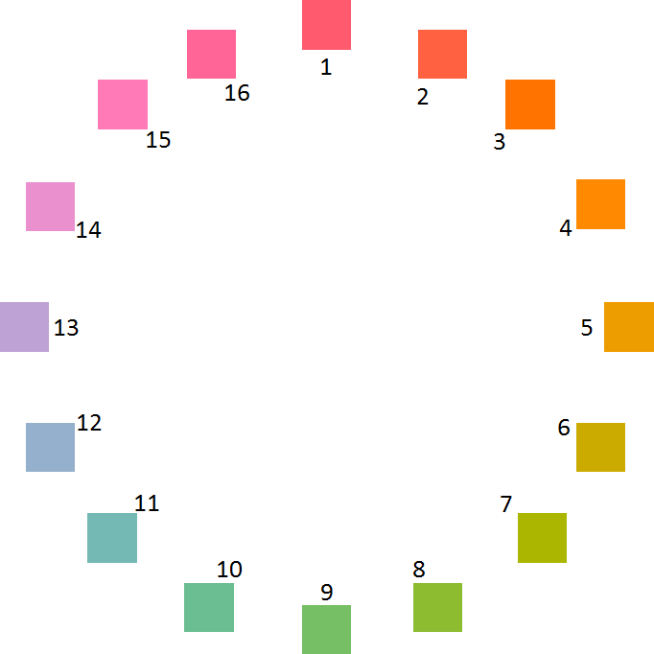

Figure 4. The material used in the Experiment 2. All the color patches are equality distributed on a color wheel which centers at set as 70, set as 20, and set as 38 with radius 60.

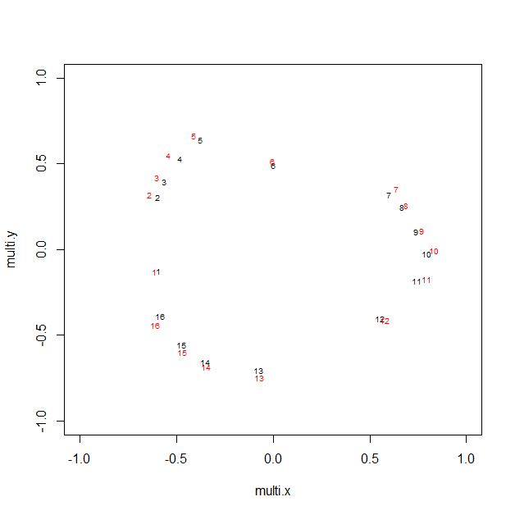

Figure 5. The MDS results of the similarity matrices acquired from the Multi-Items Rearrangement task and the Paired-Comparison task. The numbers indicate the items in Figure 4.